TRANSFORM SCRIPT: we will find it under sys_transform_map

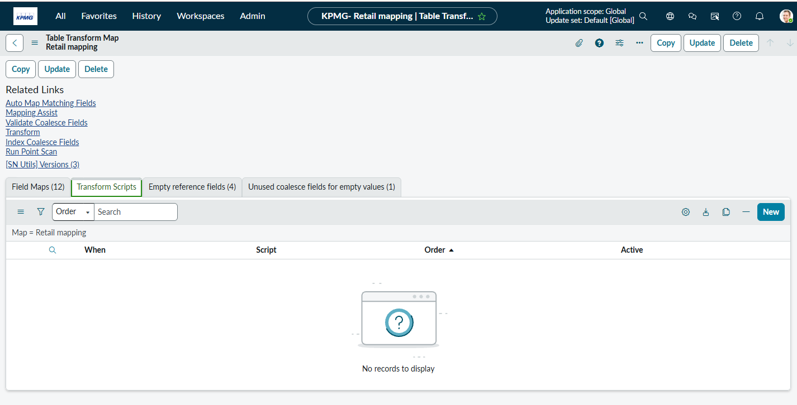
onStart()
onComplete()
onBefore()
onAfter()
onForeignInsert() runs just before ServiceNow creates a new referenced (foreign) record during a transform.
onChoiceCreate()
onReject() ----- runs only when a Foreign Record (Reference) is rejected during a transform.

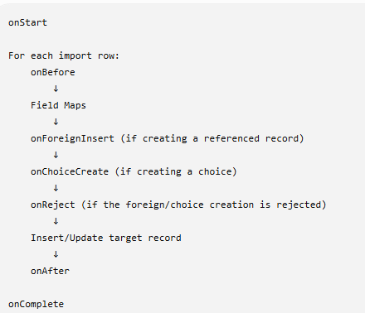
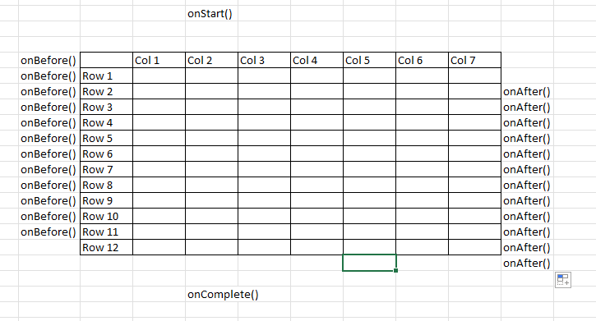

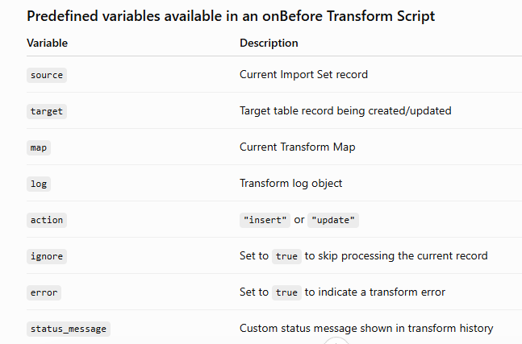
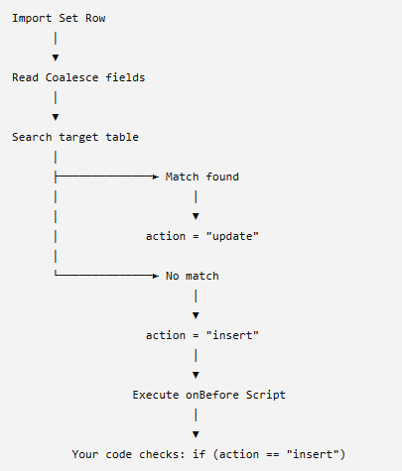

if (action == 'insert') {
ignore = true;
status_message= ‘insertion is not allowed’
}

Let have a scenario:
We want insert an record only if Assignment group at least one of the member is active.

So we right onBefore script:

(function runTransformScript(source, map, log, target /*undefined onStart*/ ) {

// Add your code here
if(action=='insert'){
ignore=true;
status_message='insertion is not allowed';
}else{

var grGroup=new GlideRecord('sys_user_group');
grGroup.addQuery('name',source.u_assignment_group);
grGroup.query();

var sysOfGroup='';
if(grGroup.next()){
sysOfGroup=grGroup.getUniqueValue();
}

ignore=true;
var gr=new GlideRecord('sys_user_grmember');
gr.addQuery('group',sysOfGroup);
gr.query();

while(gr.next()){
if(gr.user.active){
ignore=false;
break;
}
}

if(ignore) status_message="Group not having atleast one active user";

}

})(source, map, log, target);

